**Explain cloud like I’m 10**

* **Racks**: way of stuffing as many computers together as humanly possible.
* **Cloud computing** (just a service): accessing computer services over the internet.
* **Cloud** (~network of computers): big building with a lot of computers inside.
  + Cloud services run in the cloud.
  + Cloud lives in datacenters
  + Cloud sells computer as a service -> rent computer over internet.
  + The term ‘cloud’ comes from the symbol used to represent a network when drawing diagrams.

* 2 Kind of Cloud
  + Cloud provider: own datacenters, let customers rent computer to build services.
    - Responsible for maintaining and operating their computer.
  + Cloud services (Gmail, YouTube, Facebook): perform a job for you in a cloud.
    - Services: compute, memory, storage, network, bandwidth, database…
* Cloud Computing began with **EC2 (Elastic Compute Cloud) in 2007**.
  + Easy to use: anyone with credit card and internet connection can rent
  + Permissionless: Not having to ask for permission.
  + Only pay for what you use.
  + OpEx vs CapEx
  + ‘Cloud Native’ software must be able to deal with computers failing at any time.
  + Datacenters can fail at any time.
    - Cloud allows programs to failover to different datacenters -> increase reliability.

**Cloud Computing Concepts, Technology & Architecture**

**Chap 3. Understanding Cloud Computing**

* **Cloud***:* a distinct IT environment that is designed for the purpose of  
  remotely provisioning scalable and measured IT resources
* **IT Resource:**
  + **Software-based**: virtual server or a custom software program.
  + **Hardware-based**: physical server, or a network device
* **On-Premise:** An IT resource that is hosted in a conventional IT enterprise within an organizational boundary (that does not specifically represent a cloud) is considered to be located on the premises of the IT enterprise, or *on-premise.*
* **Scaling:** 
  + **Horizontal Scaling (‘Scaling Out’)**: the process of increasing the number of nodes and machines in the resource pool.
  + **Vertical Scaling (‘Scaling Up’):** the process of increasing the power of an existing system, such as the CPU or RAM, to meet the rising demands.
* **Cloud Service:** any IT resource that is made remotely accessible via a cloud (cloud service can exsist as a simple Web-based software program).
* **Cloud Service Consumer:** temporary runtime role assumed by software program when it accesses a cloud service.

**Chap 4. Fundamental Concepts and Models**

* **Cloud Delivery Models**
  + **Infrastructure-as-a-Service (IaaS**): self-contained IT environment comprised of infrastructure-centric IT resources (hardware, network, connectivity, operating systems, and other “raw” IT resources).
  + **Platform-as-a-Service (PaaS):** “ready-to-use” environment typically comprised of already deployed and configured IT resources.
  + **Software-as-a-Service (SaaS):**  software program positioned as a shared cloud service and made available as a “product.”
* **Cloud Deployment Models –** specific type of cloud environment (distinguished by ownership, size, access)
  + **Public Cloud:** publicly accessible cloud environment owned by a third-party cloud provider.
  + **Community Cloud:** similar to public cloud except that its access is limited to a specific community of cloud consumers.
  + **Private Cloud:** owned by a single organization. The same organization is technically both the cloud consumer and cloud provider.
  + **Hybrid Cloud:** comprised of 2 or more different cloud deployment models.

**Chap 5. Cloud-Enabling Technology**

* **Data Center Technology**

**Data center** (specialized IT infrastructure) used to house centralized IT resources (servers, databases, networking, telecomunications devices, and software systems).

* + **Virtualization** 
    - **Physical layer:** facility infrastructure (computing/networking systems and equipments)
    - **Virtualization layer:** operational and management tools that abstract physical computing/networking resources as virtualized components.
      * **Easier to allocate, operate, release, monitor and control.**
  + **Computing hardware**
    - rackmounted server arrays and multi-core CPU architectures
    - specialized high-capacity network hardware: content-aware routing, LAN and SAN fabrics, and NAS gateways.
* **Virtualization Technology**
  + **Virulization:** process converting a physical IT resource into a virtual one.
  + **Server virtualization:** process of abstracting IT hardware into virtual servers using virtualization software
* **Web Technology**
  + **Web applications – 3-tier model**
    - **Presentation layer:** theuser-interface
    - **Application layer:** implementation of application logic
    - **Data layer:** persistent data stores
* **Multitenant Technology**
  + Enable multiple tentnants to access the same application logic simultanously
* **Service Technology**
  + **Web services – industry standarded:**
    - **Web Service Description Language (WSDL)**
    - **XML Schema Definition Language (XML Schema)**
    - **Simple Object Access Protocol** (SOAP messages= header + body)
    - **Universal Description, Discovery, and Integration (UDDI)**
  + **REST services- 6 design constraints:**
    - **Client-Server**
    - **Stateless**
    - **Cache**
    - **Interface/Uniform Contract**
    - **Layered System**
    - **Code-On-Demand**
  + **Service Agents:** Event-driven programs designed to intercept messages at runtime.
    - Active service agents: making changes to the message content or changes to the message path.
    - Passive: do not change message content, capture certain part of its content, for logging, monitoring, or reporting purposes.
  + **Service Middleware –** 2 common types of middleware platform:
    - **Enterprise service bus (ESB):** service brokerage, routing, message queuing
    - **Orchestration platform:** host and execute workflow logic that drives the runtime composition of services.

**Chap 7. Cloud Infrastructure Mechanisms**

* 1. **Logical Network Perimeter** establishes a virtual network boundary that can encompass and isolate a group of cloud-based IT resources.

**- Virtual Firewall:**

* Similar to traditional hardware but operates as a software instance
* Actively filter network traffic entering/exiting isolated network.

**->** Protect isolated network from unauthorized access, malicious activities

**- Virtual Network** (acquired through VLANs**):** IT resource isolates the network environment within the data center.

**->** Help with traffic management

* 1. **Virtual Server:** a form of virtualization sofware that emulates a physical server.

- Used by cloud providers to provide individual virtual server instances (same physical server) with multiple cloud consumers.

- **VIM** coordinates the physical servers in relation to the creation of virtual server instances.

-> Uniform Implementation of the virtualization layer

* 1. **Cloud Storage Device**
* **Cloud Storage Levels**
* **Files**
* **Blocks –** smallest unit of data that is still individually accessible.
* **Datasets –** organized into table-based, delimited or record format.
* **Objects –** data and metadata organized as Web-based resources.

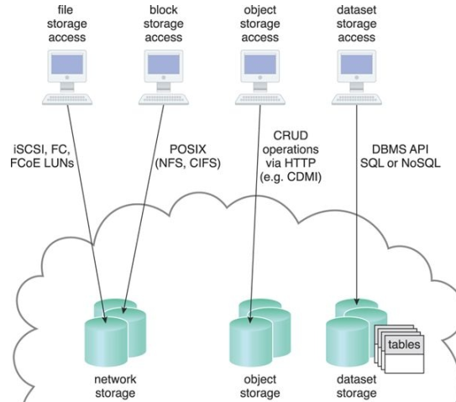

* **Network Storage Interfaces**
* **Object Storage Interfaces**
* **Database Storage Interfaces**
  1. **Cloud Usage Monitor:** software program responsible for collecting and processing IT resource usage data.
* **Monitoring Agent:** event-driven program to measure network traffic and message metrics.

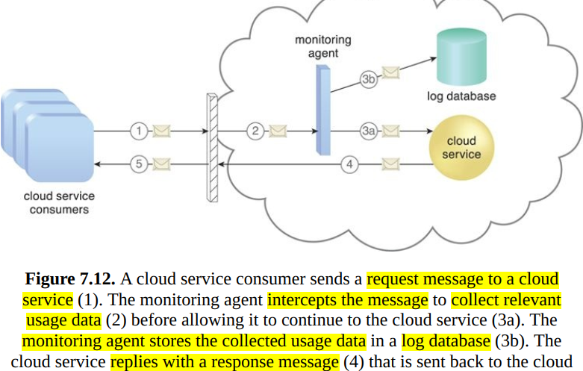

* **Resource Agent:** a processing module that collects usage data by having event-driven interactions with specialized resource software.
  + Monitor a virtual server and detect an increase in usage.
* **Polling Agent:** a processing module that collects cloud service usage data by polling IT resources.
  1. **Resource Replication:** creation of multiple instances of the same IT resource

**->** Enhance IT resource’s availability and performance

**7.6 Ready-Made Environment:** a component of the PaaS cloud delivery model

- Ready-made environments include pre-installed IT resources, such as databases, middleware, development tools, and governance tools

**Chap 8. Specialized Cloud Mechanisms**

**8.1 Automated Scaling Listener:** service agent that monitors and tracks communications between cloud service consumers and cloud services for **dynamic scaling** purposes.

**- Workloads:** volume of cloud consumer-generated requests or back-end processing demands triggered by types of requests

- **Types of responses** to workload fluctuation conditions:

* **Auto-scaling**: Automatically scale or based on parameters previously defined by the cloud consumer.
* **Automatic notification** of the cloud consumer: when workloads exceed current thresholds or fall below allocated resources (fig 8.1)

**->** Cloud consumer can choose to adjust its current IT resource allocation.

**8.2 Load Balancer** (runtime agent)

- **Objectives**: optimize IT resource usage, avoiding overloads, and maximizing throughput

- **Specialized** **runtime workload distribution functions:**

* **Asymmetric Distribution** – larger workloads are issued to IT resources with higher processing capacities
* **Workload Prioritization** – workloads are scheduled, queued, discarded, and distributed workloads according to their priority levels
* **Content-Aware Distribution** – requests are distributed to different IT resources as dictated by the request content

**-**  The load balancer mechanisms can exist as a:

* multi-layer network switch
* dedicated hardware appliance
* dedicated software-based system (common in server operating systems)
* service agent (usually controlled by cloud management software)

**8.3 SLA (Service Level Agreement) Monitor:** observe the runtime performance of cloud services to ensure that they are fulfilling the contractual QoS (Quality of Service) requirements(published in SLAs).

- Collected data are aggregated into SLA reporting metrics -> repair or failover cloud services

**8.4 Pay-Per-Use Monitor:** measures cloud-based IT resource usage by predefined pricing parameters and generates usage logs for fee calculations and billing purposes.

**-** Some typical monitoring variables:

* request/response message quantity
* transmitted data volume
* bandwidth consumption

**8.5 Audit Monitor:** collect audit tracking data for networks and IT resources in support of regulatory and contractual obligations

**8.6 Failover System:** automatically switch over to a redundant or standby IT resource instance whenever the currently active IT resource becomes unavailable

- Commonly used for mission-critical programs (like financial system) and reusable services (preventing a single service failure from impacting all dependent applications)

- **2 Basic configurations**:

* **Active-Active**: Redundant implementations of the IT resource actively serve the workload synchronously. When a failure is detected, the failed instance is removed from the load balancing scheduler. Whichever IT resource remains operational takes over the processing
* **Active-Passive:** A standby or inactive implementation is activated to take over the processing from the IT resource, and the corresponding workload is redirected to the instance taking over the operation

**8.7 Hypervisor** (software): generate virtual server instances of 1 physical server

- A hypervisor is limited to 1 physical server -> only create virtual images of that server

- VIM provides features for administering multiple hypervisors

**8.8 Resource Cluster:** combine multiple (geographically diverse) IT resource instances into a single IT resource (cluster) -> increase computing capacity, load balancing, and availability.

- Common **resource cluster types** include:

* **Server Cluster**
* **Database Cluster**
* **Large Dataset Cluster**

**8.9 Multi-Device Broker:** gateways contain the **mapping logic** to

transform data exchanges between a cloud service and different types of cloud

service consumer devices

**8.10 State Management Database: storage device** that is used to temporarily

persist state data for software programs.

- As an alternative to caching state data in memory, software programs can off-load state data to the database in order to reduce the amount of runtime memory

- State management databases are commonly used by cloud services, especially those involved in long-running runtime activities.

**Chap 9. Cloud Management Mechanisms**

**9.1 Remote Administration System:** provide tools and UI for external cloud resource administrators to configure and administer cloud-based IT resources.

- Cloud provider uses tool and APIs (provided by remote adminstration) to develop and customize online portal for cloud consumers -> provide administrative controls.

- **2 primary types of portals:**

* **Usage and Administration Portal -** General Purpose Portal:
  + centralizes management controls to different cloud-based IT resources.
  + provide IT resource usage reports.
* **Self-Service Portal** – Shopping Portal that allows cloud consumers to search an up-to-date list of cloud services and IT resources that are available from a cloud provider (usually for lease). The cloud consumer submits its chosen items to the cloud provider for provisioning.